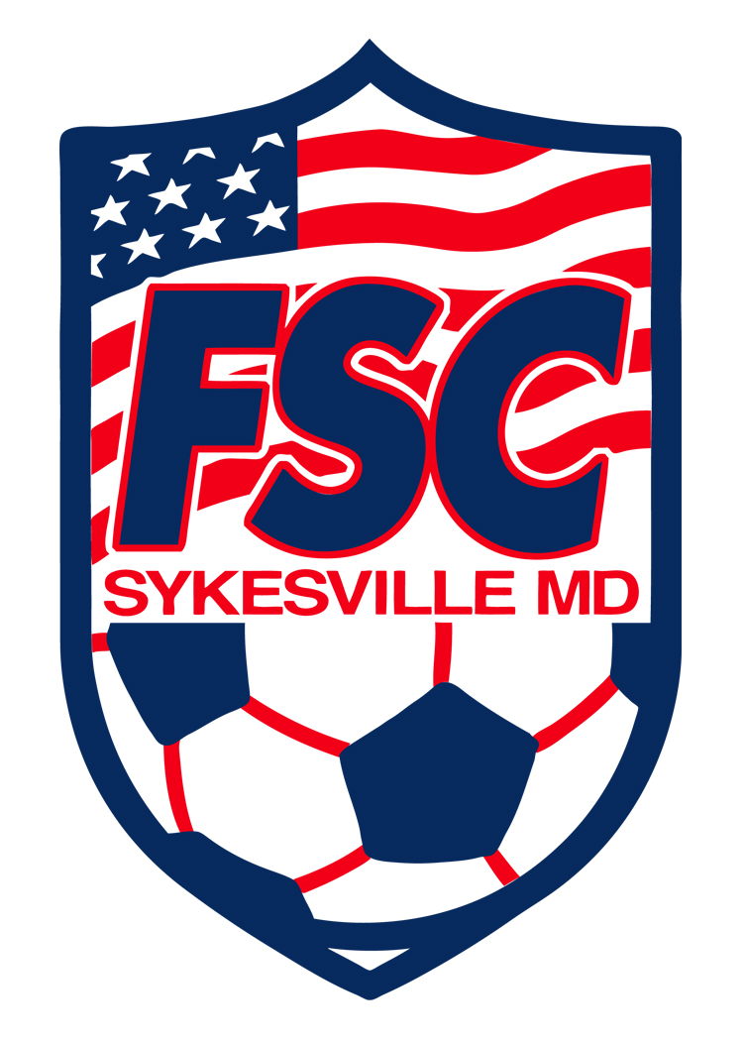

Freedom Soccer Club
Financial Assistance Application Packet

FSC Financial Assistance Policy
Freedom Soccer Club (FSC) is devoted to promoting youth soccer in Carroll County and surrounding areas. FSC makes their selections without regard to a player’s ability to pay. FSC provides financial assistance, for those who qualify, to players whose families cannot afford to pay the full cost of participation.
Those requesting financial aid for club and/or team fees should submit an FSC Financial Assistance Application to the FSC Financial Assistance Committee. While financial aid funds are limited, this program makes this opportunity available to those in need in our community.
If approved for FSC Financial Assistance, the player’s financial responsibility will be at least 50% of the required fees.
FSC Financial Assistance will be approved by the FSC Financial Assistance Committee if:
- The player requesting the financial assistance is on the federal free or reduced lunch program.
- The family’s combined income would qualify them for the federal free or reduced lunch program.
Other extenuating circumstances (immediate family member with serious medical condition, recent loss of job, etc.) may be considered by the Financial Assistance Committee.
FSC Financial Assistance does not cover expenses such as transportation to practices, games, or tournaments.
FSC requests that players remain current with all club and team fees.
Please submit your completed application to your Team Manager, Team Treasurer or Head Coach by October 31st. Applications received after that date may not be able to be considered. Financial Assistance offers may vary from year to year based on qualifications, team fees, the number of players applying for assistance and funds available. Completed applications or questions may also be submitted to financialassistance@freedomsoccerclub.org.

Freedom Soccer Club
Financial Assistance Application
Part I: Personal Information

Player’s Name_____________________________________________________________ Birth Year ______________

Parent/Guardian Name(s)___________________________________________________________________________

Address__________________________________________________________________________________________

Email_______________________________________________ Cell Phone________________________________

Part II: Federal Free or Reduced School Lunch Program

Do you currently receive financial aid in the form or free or reduced public school lunch program?
□ Yes – attach verification and skip to Part IV □ No – continue to Part III

Part III: Income
Number of dependents in your household _______________________________

Mother’s/Guardian’s Current Annual Income _______________________________

Father’s/Guardian’s Current Annual Income _______________________________

Other Family Income (Alimony, Child Support, etc.) _______________________________
Please provide copies of your most recent paystubs and prior year tax return and verification of other income. Your application cannot be processed without these documents. Your application may be retained by the club but all of your supporting documents, copies &/or originals, will be returned within 7 days or committee meeting.

Part IV: Type of Financial Assistance
Check all items for which a scholarship is being requested:
□ FSC Annual Club Fees ($200)
□ Team Fees – Fall (please specify amounts) _____________________________________
□ Team Fees – Spring (please specify amounts) ___________________________________
□ Other (please specify amounts) ______________________________________________

Team Name__________________________ Head Coach’s Name ______________________________________

Part V: Signature
I agree the above information contained in this document is true and complete to the best of my knowledge. I am aware that I must pay at least 50% of my player’s Club and/or Team fees if awarded financial assistance.

__________________________________________ _________________________________
Parent/Guardian Date
The above signed individual(s) state by signing this document that the information contained is true and complete to the best of their knowledge.

If you have any other extenuating circumstances that would be helpful when considering your application, please describe them on the reverse of this page.
(Optional) If you have any other extenuating circumstances that would be helpful when considering your application, please describe them below.

_______________________________________________________________________________________________________________________________________________________________________________________________________________________________________________________________________________________________________________
____________________________________________________________________________________________________________________________________________________________________________________________________________________________________________________________________________________________________________________________________________________________________________________________________________________________________________________________________________________________________________________________________________________________________________________________________________________________________________________________________________________________________________________________________________________________________________________________________________________________________________________________________________________________________________________________________________________________________________________________________________________________________________________________________________________________________________________________________________________________________________________________________________________________________________________________

